11.27: a) The top wire is subject to a tension of 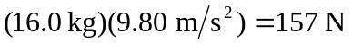and hence a tensile strain of 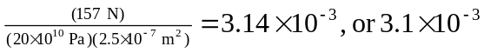to two figures. The bottom wire is subject to a tension of 98.0 N, and a tensile strain of 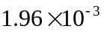, or 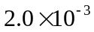 to two figures. b) 